11.Powerful Presentations QM3 Create & Insert with Microsoft PowerPoint
11. Powerful Presentations | QM3 Create & Insert 1 class period
Overview of this thing: Tired of writing all the time? Would you like to express yourself through a presentation instead? During these Quests you are going to learn how to present your ideas creatively through Google Slides or Microsoft PowerPoint. If you would like to try Prezi as an option use the Gold Quests There are two tracks, one for users of Google Slides, and another for Microsoft PowerPoint.

This Quest: Students will use the tutorials to help you build their own skills and add features to their presentation. We suggest you create a blank presentation to practice with, and then decide if you want to add some to your own presentation, or work with your partner or group to decide on the most effective ones to support your message or topic.

Broken Link or Content Update Report
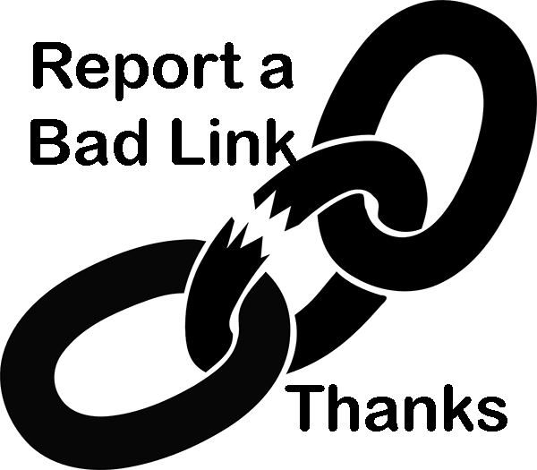Please select this link or the broken link icon to report any broken links, or content no longer applicable so that we can quickly update it. Thank you for your help.

Learning Objectives:
- know how to use a variety of media to create and collaborate on an effective presentation [Global Collaborator]​
Quizlet and link to pre-check: Vocabulary Quizlet
Vocabulary Quizlet Main Link: Vocabulary Quizlet Main Link

Vocabulary
- Design: Professionally designed ideas and layouts that can be applied to a slide or entire presentation to improve the visual appearance of it.
- Handles: This refers to the sizing handles that appear around an image that let you resize and rotate the object selected.
- Preview in the Desktop app: This action lets you see how the presentation or a slide will look before completing and saving it.
- Ribbon: This is a long strip of tabs with buttons across the main window in PowerPoint.
- Slide Background: The slide is initially plain white, but can be changed to a solid color, gradient color fill, a texture or pattern, or a photo or image. Note that a "Theme" you apply may override individual slide backgrounds.
- Slide Layout: a layout is the way your text and images are arranged on a slide. Applying a "Theme" may change the layout of the slides.
- Tabs: Collections of tools such as Insert, Draw, Design, Animations that can be used in creating a presentation.
- Theme: refers to a design theme that makes it easy to coordinate your PowerPoint presentation with colors, graphics, and fonts that all work together to create a mood for your presentation. Default themes are provided in the program.
- Thumbnails: Miniature images of slides in a presentation.
- Tools: Features in the PowerPoint program that help you apply an action, such as inserting images, shapes or videos, and adding effects to objects on a slide.
Pre-Planning
- Point out that they should make sure they are using the pages for Microsoft PowerPoint and don’t use the Google Slides Quests (an easy mistake).
- Point out to students which application of PowerPoint they are using: 365 online in the browser or the Desktop app. There are different videos for each.
- Students will create a Blank presentation for these practice activities.
- Students should be prepared to pause the video (or the teacher can do this if showing it to the entire class) so they can try-out each feature.
- Point out how to locate the bookmarks along the bottom of the video player so they can replay and access specific sections.
- When done students should refer to their planning document from Quest 2 and begin adding some of these features to their Planned Presentation.
- If they are working with a partner or group, they will need to come to come to consensus on a theme to apply to their single Group Presentation so that the Presentation “Driver” can apply it.
- Direct them to name it with a group name and save it in an appropriate drive space.
- Mention that the next Quest will have some additional and more advanced features to practice and learn.
- If students say they know all these skills already (list below), you may ask them to take a turn and demonstrate them, or allow them to move on to the next Quest.
List of PowerPoint skills to know and try out that are shown in the Introduction videos :
- Title and subtitle
- Add a new slide and layout options
- Themes
- Background Color choices
- Background Image choices
- Additional Background Options
- Insert Pictures, Shapes, and Images: resize, rotate, and overlap
Websites
- GCF LearnFree PowerPoint Tutorials
- Basic Tasks for Creating a PowerPoint Presentation- Microsoft Support
21t4s Videos
- Introduction video: PowerPoint in 365 in the Web Browser Video
- Introduction video: PowerPoint Desktop app Video
21t4s Documents & Quizzes
- Vocabulary Quizlet
- Vocabulary Quizlet Main Link
Helpful tutorial videos or extra resources for the teacher for this Quest

MICROSOFT POWERPOINT
- PowerPoint Online Tutorials GCF LearnFree.org
- Basic tasks for creating a PowerPoint (365) Microsoft support
Student Checklists
- 11.QM3 Student Checklist

Assessment Options:  Ideas for assessing student work for this Quest? Link to a rubric you create for this Quest, a quiz, and or a worksheet you create. See Rubric by Liz Kolb. | Student group collaboration observed  Theme and initial slides created and being worked on
Notes:

