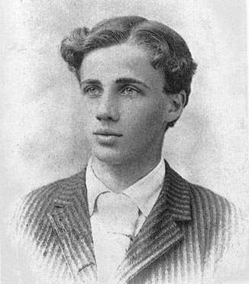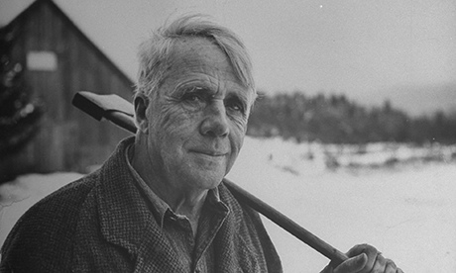

Short bio of Robert Frost for the 21things4students

Robert Frost was born in San Francisco, California on March 26, 1874 and died January 29, 1963. He grew up in the city, and published his first poem in his high school magazine. He received four Pulitzer Prizes for Poetry during his lifetime. His father was a teacher and journalist of English descent, and his mother was of Scottish descent. Frost worked at various jobs, delivering newspapers, in a factory, and teaching, but he really loved writing poetry. He sold his first poem for $15 when he was 20 years old. He went to college, was married, had six children and moved to a farm where he wrote early in the mornings. He was a college teachere for forty-two years, moving around frequently and spent his summers in mountain areas of Vermont. When President John F. Kennedy was inaugurated (January 20, 1961) he did a personal appearance and read aloud one of his poems. The Oxford University Press mentioned that his poetry frequently presents pessimistic and menacing undertones and yet can be charmingly familiar with a rural facade.

