4. Google Docs in 21things4students Part 2

Poem by Robert Frost for 21things4students Thing 4 Quest 1 part 2

The videos can be viewed in a separate window, tab, or separate device while you work on formatting this poem. Revised fall 2020

Part 2 has fun things like adding page numbers, word count, translating it to a foreign language, Version history, the Explore tool, the Task List, and sharing it with your teacher!

CK box | STEPS
 | Open your Poem document
 | - Word count Tool: sometimes you need to know how many words are in your document, for an assignment or an application. Look at the menu and locate Tools. Click on it to see how many: Pages, Words, Characters, and Characters without spaces. Sure saves a lot of time trying to count them. | 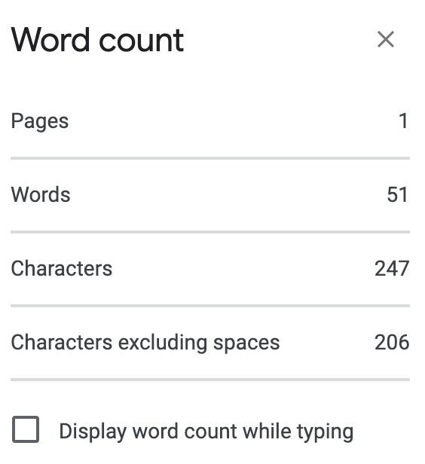
 | - Page numbers: Look at the Insert menu. You can select where on the page to put your page numbers, or under More Options in that menu you can decide if your page numbers should be in the header or footer, show or not show on the first page, and what number to start with.  Select Footer and Show on the First Page | 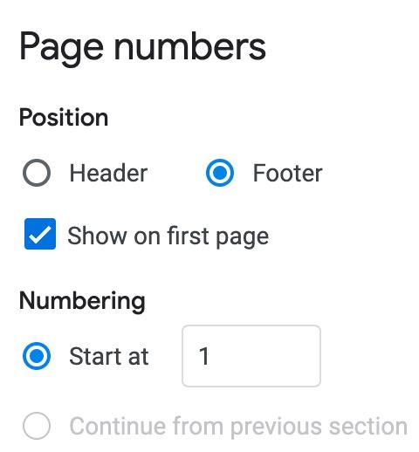
 | - Translation please: If you are learning a foreign language, or have a friend in another country, you can have your document translated! Go to the Tools menu and select Translate, then choose a language from the list. It only takes a few moments.
 | - What happens when you have it translate back to English? It may just be different!
 | - Version History: Go to the file menu, select Version History  Note to the Wise!  It may take 10-25 minutes before you see the different versions, but you can revert back to an earlier version in case you accidentally deleted something you meant to save. | 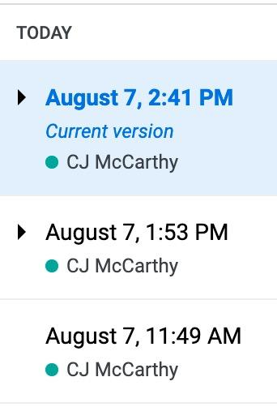
 | - Explore (in the Tools menu) and also as a floating icon near the bottom of the page. | 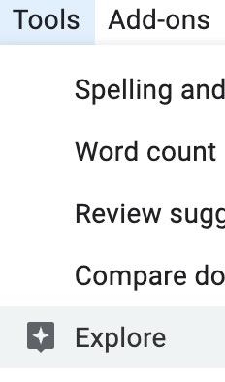
 | Click on the Explore icon and type in the Search menu (or copy and paste) Robert Frost.  Try searching Eden. | Wow right?  And at the bottom of the list is “See all the results…”
 | - Task List Find out if this is enabled for your Drive. If it is enabled, you will see it in your different Google Suite Documents. You can use it to make ToDo lists, reminders, study notes, organize your day/week. And you can check them off when done.
- Share your Poem document with your teacher.
Ask how they want you to share it, and then select the Share icon and either add them to the document or get a URL link to share.
 | Much more fun to come with inserting images, photos, videos, and more in the next Quests.

Congratulations on learning Formatting and special features in Google Docs.

