Design Thinking Workbook

Quest 1: What is Design Thinking?

Design Thinking is a process for creating a solution to a problem. It’s similar to what you might do in a science class, math class or social studies class. Design thinking tends to work really well for creating solutions to problems that impact humans, like creating a new type of food that can be distributed to areas stricken with famine, a new type of transportation for people in big cities or a YouTube channel that inspires others to be their best self.

There are many models for the design thinking process and each one highlights different aspects of the design process. In this thing, you’ll be using design thinking to guide and track your progress to a solution to a real-world problem. Watch Sprout’s video The Design Thinking Process (3:56) to get an overview of the things involved in a design thinking process.

You’ll notice that this video follows the Design Thinking Model created by Stanford d.School that looks like the image below. We’ll be using this model as our guide and add some important bits to it as we explore design thinking together. A design thinking process can help you solve some of the hardest problems or some of the silliest. It’s up to you!

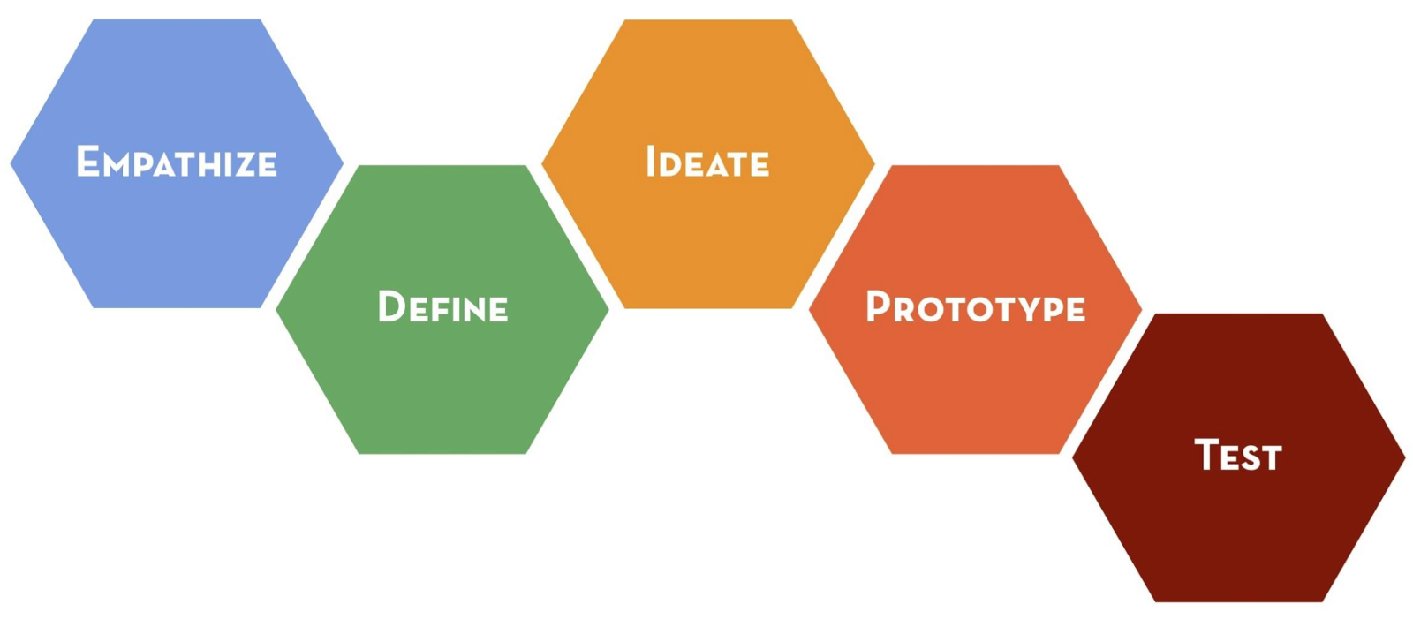
Source: Stanford d.school’s Design Thinking Bootleg

Assemble your Team
Design Thinking works best with teams of 2 to 4. Refer to your teacher for directions on how to assemble your team. It’s best if you include teammates with different backgrounds and strengths because different perspectives shape a better solution.

Download Your Workbook
Download a copy of the Design Thinking Workbook. You’ll use this to keep track of your thoughts and progress through this Thing.
Link to PDF for printing
Link to Google Doc
Link to Microsoft Word Doc

Share your Workbook
Since this workbook will be shared by your team, you may choose to print it and write or draw on it or use it digitally in Google Docs, Microsoft Word, or another tool that you and your teacher agree upon.

If you choose to print a copy, refer to your teacher for safekeeping. You may want to find a special place in the room to store your workbook or elect a teammate who will be responsible for bringing it each day.

If you choose to go digital, share the document with each teammate and your teacher. Refer to your teacher for their sharing preference, they may want you to share it in your learning management system.

Quest 2: What’s your problem?

In this Quest you and your team will begin the design thinking process by looking for problems to solve. To discover real-world problems you’ll need to listen and observe to develop an empathy with all sides of the problem. Ultimately, you’ll define the problem you are going to solve and how solving this problem will make a difference.

Identify a Problem
Generate at least three problems in your community that affect you, someone you know or your entire community. Look for problems in your daily life that could be solved by creating an object or a process. Record your problems in the table below.

Not sure where to start? Ask your friends, teachers or family members about problems in their lives. Still stuck? Check out 80,000 hours to find some social issues affecting people globally.

1
2
3

Choose your favorite problem that you want to design a solution to.

I’m going to solve

Dig Deeper with Research
Use your skills from Thing 9: Search Strategies to research the problem you chose. Identify things that help you understand the problem better like who it affects and how it affects them. Make sure to cite the places you visit in the table below.

Notes | Site

Empathize
Understanding the problem from the eyes of of the person who is affected is an important part of designing something to solve a problem. Watch the following video about empathizing in Design Thinking.
IDEO’s Empathy Video: Whose Life (5:03)

Who is affected by your problem? How are they affected? How might they feel about this problem? Describe their emotions.

is/are feeling

about

Define
Describe your problem. How will solving this problem make a difference?

Quest 3: Big Ideas

The next stage of the design thinking process is ideation, where you’ll generate lots of ideas that might help to solve the problem you selected in Quest #1. At the end of this Quest, you’ll select your most promising ideas, highlight the best parts of other ideas and ultimately choose an idea to start pursuing.To brainstorm effectively, here’s a few ground rules adapted from IDEO on brainstorming.
- Don’t judge. There are no bad ideas.
- Encourage wild ideas. Focus on possibilities, not constraints.
- Build upon the ideas of your teammates or other’s who’ve tried to solve the same problem..
- Stay focused on solving your problem. Don’t get distracted by ideas that don’t solve your problem.
- One conversation at a time.
- Be visual. Put your ideas in a place where others can see them.
- Go for tons of ideas. There are no bad ideas.

Brainstorm
Set a 10 minute timer. When you press start, generate as many ideas as you can possibly think of. Record them in the space below.

Ideas
More Ideas

Develop
Put a star next to three of your most promising ideas. Develop them a little bit further. Sketch or describe a quick rough draft of each idea in the table below. You can sketch on paper then take a picture and put it in the space below if you’re doing this digitally without a drawing option.

Consider
Which idea do you feel is the best for solving your problem? Put a star next to it in the table above.

What are the best features of your other ideas? Can you incorporate them into your best idea?

I am creating a |  | For

So that

Quest 4: Prototypes

Next you’ll be creating something physical (an object, a visual, a presentation) to test your idea and convey it to others. It should be something that can be held or seen. Remember that a prototype does not need to be pretty or functional to convey your idea.

Check out the following video on YouTube: What is Prototyping? (1:17)

Research
Use your research skills from Thing 9: Search Strategies to draw inspiration for your design. You may consider the types of materials, similar designs, the environmental impact of your solution and other considerations for your idea. Record your notes in the table below.

Notes | Site

Rough Draft
Create a rough draft of your idea in the space below. This can be done by drawing or outlining your idea. Remember that this is intended to be very quick; don’t spend a lot of time on it.

Select and Gather Materials
Choose a medium that will best help you test and demonstrate your idea. Is your idea best seen digitally or on paper? Does it need to be held in someone’s hand?

Physical | Digital
- Play Doh  - Legos  - Craft supplies (popsicle sticks, construction paper, glue, scissors, pipe cleaners, yarn, etc.)  - Poster board  - Photos  - Sketching and Paper Prototyping (for apps and websites) | - TinkerCAD  - Minecraft EE  - Google Sites  - Google Slides  - Google Drawings  - Adobe Spark  - Microsoft Sway  - Bubbl.us

Build
Create your prototype. Take a screenshot or picture of your prototype and paste it into the space below. If your design is easier to link to, attach a hyperlink to your prototype in the space below.

Quest 5: Test and Improve

Now it’s time to test out your prototype to see if it solves your problem. Your goal during testing is to gather feedback to improve your design. Listen to others who are testing your prototype and take notes of the things they say and do that you could improve upon. Gather data for how well your prototype solved your problem and use it to improve your design.

Watch the following two videos to build your own ideas about prototypes and testing. The first video (4:01) talks about both prototyping and testing your prototype.
This second video, also from YouTube (4:49), talks about How to Test a Prototype with REAL people: User Testing a Functional Prototype

Alpha Testing
Partner up and describe your the problem you are trying to solve. It is ideal to test your prototype on someone who might actually use it, if possible. Then share your idea and prototype. Let your partner(s) interact with your design. Listen and observe them interacting with your design. Encourage them to share at least one thing they like, one question they have and one thing to improve on and take notes in the table below.

Things they like | Questions they have | Things to improve

First Iteration
Now that you’ve gathered feedback, improve your prototype.
- Use the “Things they like” to highlight these features in your prototype.
- Use the “Questions they have” to improve your design to make the answers to these questions apparent.
- Use the “Things to improve” to improve your design to make it better solve your problem.

Take a picture of your prototype after it’s first iteration and put it in the space below.

Beta Testing
Partner up again and share the improvements you made based on their feedback. Let your partner(s) interact with your design. Listen and observe them interacting with your new design. Encourage them to share at least one thing they like, one question they have and one thing to improve on and take notes in the table below.

Things they like | Questions they still have | Things to improve

Second Iteration
Now that you’ve gathered feedback, use it again to improve your prototype.

Take a picture of your prototype after it’s second iteration and put it in the space below.

Note that in the interest of time, we won’t have you iterate again. In the real world though, designers iterate multiple times and with different people in order to create their best possible solution to the problem.

Quest 6: Reflect and Share

Reflecting upon your learning and the design thinking process is an important step in any design thinking process. You can think of learning as a way to improve your creativity and innovation skills. Lastly, the ability to communicate your problem and sell your solution is an important skill in any profession. In this Quest, you’ll be creating a pitch to help you share your ideas.

Reflect
- How does your final prototype solve your initial problem?

- What are the most important features of your design? What makes your solution unique?

- How might the people affected by your problem feel about your solution?

- If you could start again at the beginning, what would you do differently?

- What are the advantages and disadvantages of using a design thinking process?
Advantages | Disadvantages

The Pitch
Use the skills you developed in Thing 11: Powerful Presentation to create a presentation that will encourage others to get involved with your solution. Select and use the best tool to share your problem and solution. Your presentation should include:

- Create a name for your solution.
- Introduce yourself and your team.
- Answer the following questions:
  - What is the problem you’re trying to solve? (Refer to Define in Quest 2)
  - Why is it important for the problem to be solved? (Refer to Empathize in Quest 2)
  - How does your design uniquely solve your problem? (Refer to Reflect in Quest 6)
- Show your final prototype and describe the important features of your design. (Refer to Second Iteration in Quest 5)
- Explain how your audience can get involved.
  - Can they help you build more prototypes? Test and provide feedback to help you improve? Fund your efforts? Share your idea with other people?
- Thank your audience and leave a way to contact you about your solution.

