Student Checklist

Thing: 4. Microsoft Word 365 Quest: QM2 Sharing & Collaboration
Objectives:
- know how to set permissions for a document to be shared, edited, viewed, commented on by others
- share your documents with others electronically
- know the difference between synchronous and asynchronous

Ck off | action | Step directions with illustrations
- Watch the video at the top of the page
Pause and play frequently as you do the steps

Reminder: Windows computers use ctrl for actions,
Macintosh uses the cmd key,
right-click can be done with a track pad action or a mouse.
Chromebook, you can press or tap the touchpad with two fingers, or pres Alt and click with one finger.
 |  | - Open Office 365 (in one browser tab, keeping the 21things Quest page in another tab) OR Open Word in your Desktop App
 |  | - Open your Poem document
 | Select Word
 | Part 1  1. Open your Poem document from Quest 1 in the Microsoft 365 Online account in your browser | - You can type the name you saved it as, ‘poem’ , to locate it quickly…  - OR Look in Recent, 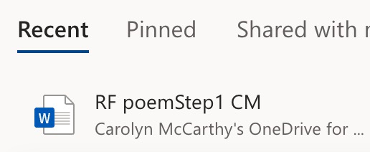  - OR go to OneDrive  and locate the file, or a folder you may have created for your 21things work. 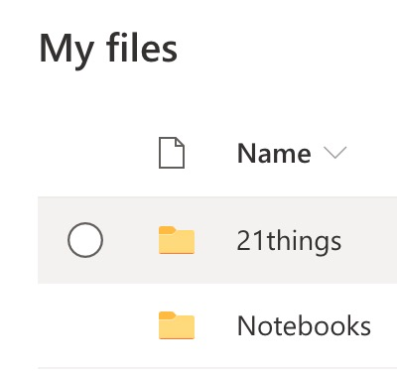  - Open your poem document from Quest 1
 | OR using the Word desktop app, look in File>Open Recent | 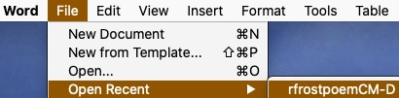
 | Step 2. | - Watch the Video embedded in Part 1
 | Steps 3 & 4 Share your poem document with your teacher | - Use the Share  - Select the permission by expanding the permission  - Set it to allow Editing permissions for your teacher by checking the box  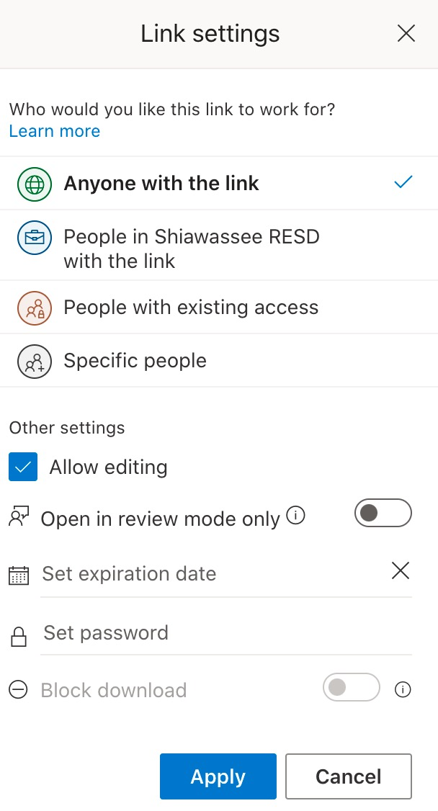  and APPLY it
 | 5. Enter your teacher’s email address | Paste your teacher’s email address into your blank document (shortcut – ctrl-v, cmd-v) exactly as it is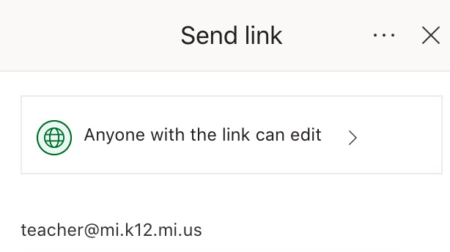
 | 6. Add a message | Add a message to let your teacher know you are sending your Poem document and include your name.  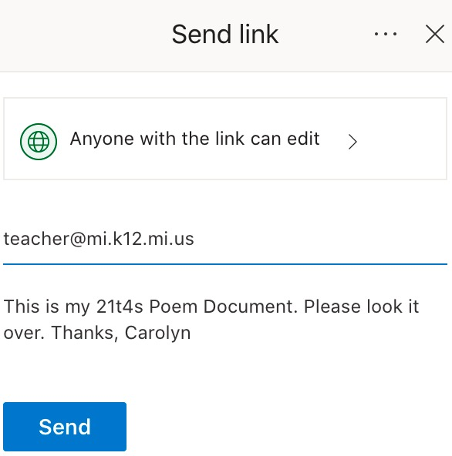  Select Send or Share.
 | Note: | This is an example of "asynchronous" collaboration. Check out the definition on Dictionary.com.
 | Part 2 Prepare a Document Step 1 | - Create a new blank document in Word:  - Select the File menu, and select New.  (Online image) ( Desktop app Image)
 | Step 2 | - Name your document “Analysis by…. “(your name or initials)  - 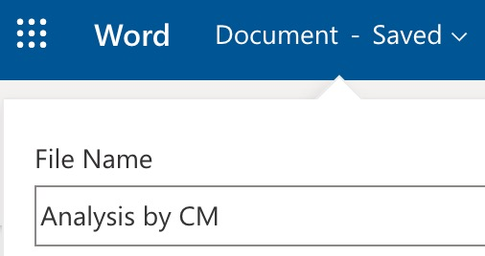  Word Online: select Document – saved and type the name Analysis by… and notice the name appear on the browser tab and where it said document.  - Desktop App: go to the File menu and select Save As… name it Analysis by …and note or decide where to save it.  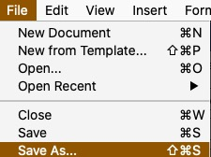
 | Step 3 | - Type "Author" and your name on line one and "Edited by" on line two for your partner to fill in later
 | Step 4 | - Copy the sentence in italics below and paste it into your document:  In Nothing Gold Can Stay, some say that Robert Frost's message is, "nothing can last forever, especially something perfect and beautiful."​
 | Step 5 | - Copy and paste the following two prompts for you to type in your analysis. Questions to think about and/or discuss with a classmate or class:  - What examples from the poem help reveal the message?  - Write about a time in your life when you had an experience that seemed perfect, but you knew would come to an end  Example: 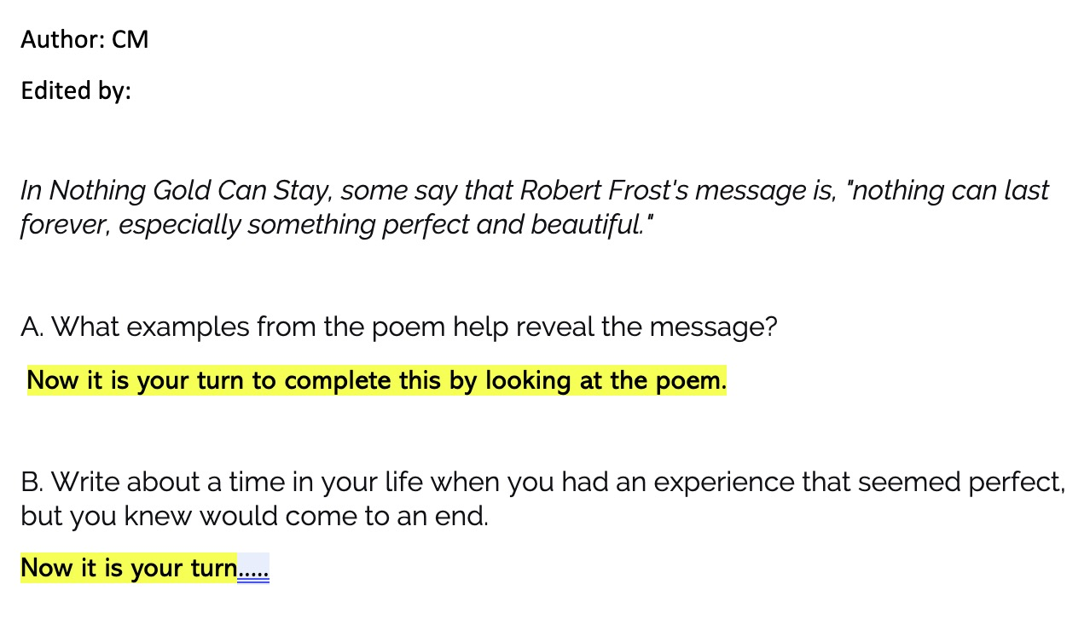
 | Part 3 | - When you have completed the previous steps, and you have saved your document, check with your teacher about who to share your analysis document with:  - Open your partner’s document in a new tab  - Select Edit Document  - Select Edit in Browser  - Enter your name after the words “Edited by”  - Read what your partner(s) has/have written  - Add some of your own ideas under each of theirs. Type your initials in parentheses (xx) after or before each comment.  - Read what your partner(s) has/have written  - Add some thoughtful comments, questions or examples to what they wrote  - Talk with your partner(s) about this sharing and collaboration experience. How could this be helpful for other classes and assignments?
 |  | Check the definition of synchronous.
 |  | Check with your teacher about turning in your document.
 |  | Check off this 4.QM2 Sharing Quest in your Roadmap document

