4.QG1 Google Docs in 21things4students

Poem by Robert Frost for 21things4students Thing 4 Quest 1

The videos can be viewed in a separate window, tab, or separate device while you work on formatting this poem. Revised fall 2020

CK box | STEPS for Part 1
 | 1. Create a new folder using the +: in your Google Drive space,
 | 2. Name it (with your first name, last initial and 4.Q1, or SuiteTools, or some other title that is helpful to store your work for this thing). | New Folder  ______ 4.Q1 xxx  Create
3. Open the folder by selecting it, and
4. Create a New Document
 | 5. Copy and paste EXACTLY the poem in the next box into your document with the errors present (or type it in exactly).
Nthing Gold Can Stay
Nature’s first green is gold,
Her hardest hue to hold,
Her early leaf’s a flower;
But only so an hour.

Then leaf subsides to leaf.
So Eden sank to grief,
So dawn goes down to day.
Nothing gold can stay.
By Robert Frost

 | FORMATTING STEPS
 | 6. Put your mouse cursor at the beginning of the first line before Nthing | 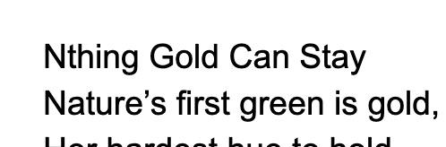
 | 7. Select the spell check icon on the menu bar to turn on spelling and grammar check
 | 8. This will open a Spelling and Grammar box that shows any errors and suggested changes.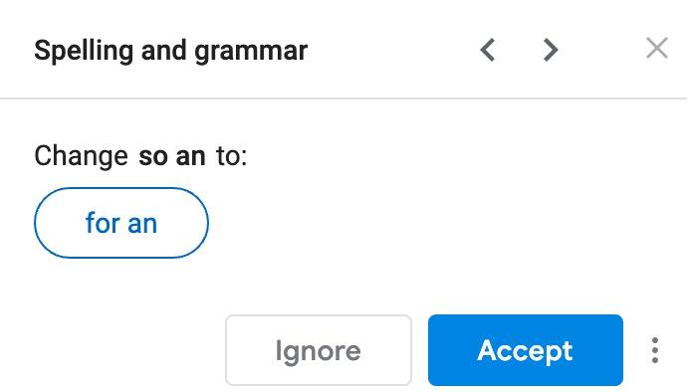
 | 9. It also highlights the misspelled word on the page (we misspelled it for this example). When it shows Nthing as an error, select Accept to accept the corrected text to spell Nothing correctly. | 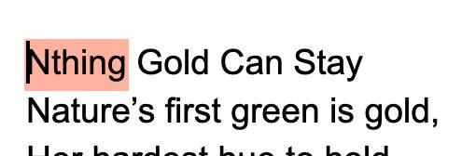
10. It moves to the next error, a grammatical one,”so an”
but select Ignore. Robert Frost wrote on purpose.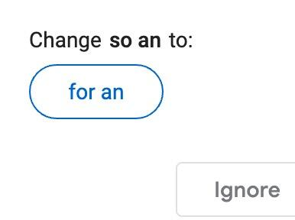

 | 11. Ignore the next one as well for the same reason (“to day”) is not the word today, but two words.
 | 12. Put a blank line or space between the first line (the title) and the poem. To do this press enter or return after “Stay” at the end of the first line. | 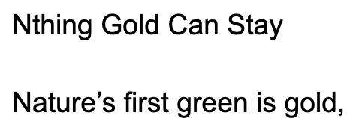
13. Save your document with the title by clicking in the space at the top that says Untitled document
It will automatically take the first line of the document as the title.
Add to the document name: You can add your first initial and last name or the date up in that title space or select a new name.
 | 14. Steps to change the Text (font) of the entire poem. Select the Edit menu and ALL text (or use the shortcut ctrl-A or cmd-A:
 | 15. Text font and size: Change the text style from Normal to a different font of your choice (such as Comic Sans) using the drop down arrow.  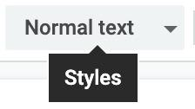  16. Then with it still all selected, change the Size of the font to 14 (or select all again so it changes all of it).  Deselect the highlighted text: Then unselect the text by clicking anywhere on the page  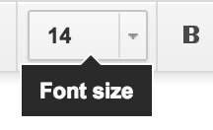 | 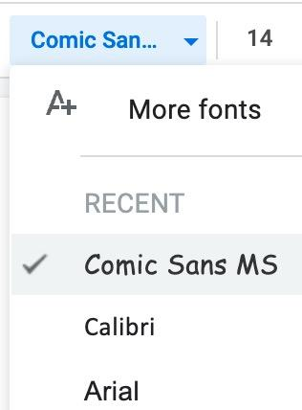
 | 17. Format the Title:  Select all the text in the first line of the poem. (triple-click, or drag across.  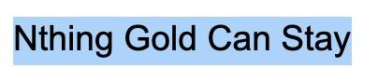  Change the Text Style from Normal to Title | 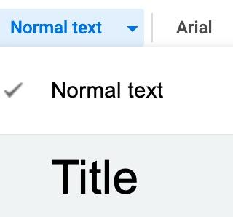
 | 18. Find “Eden” in the second stanza (part) and select it (double-click) and Bold it (cmd-B or ctrl-B) | 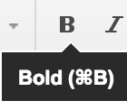
 | 19. Select the Authors Name at the end and use Italics on the menu
 | 20. Underline the Title by selecting the title and then the Underline symbol on the menu bar
 | 21. Color the text ‘color words’ so that the word green has green text. Select the text, then change the color using the to choose a green.  Change the word gold color.  Use the Highlighter tool and highlight “leaf’ with a highlight | 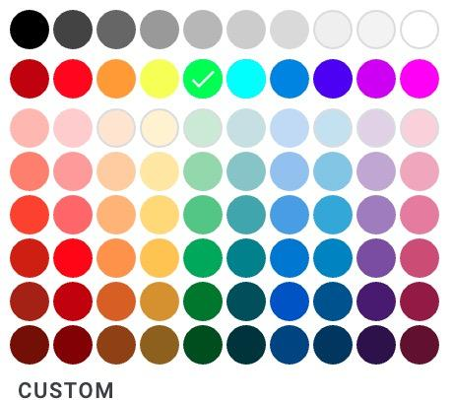
 | 22. Align: Click anywhere in the title, and choose the center alignment
 | 23. Add your credits: Below the Author’s name, space down a line or two and add: Formatted by ….. With your initials or name. Select a fun font for your name.
 | Check your work.

Part 2 is next, and some fun things like adding page numbers, translating it to a foreign language, using the Explore tool, the Task List, and sharing it with your teacher!

