Thing 4.QM1

Download this document and either add it to your OneDrive, or where you save your Desktop app documents.

4.QM1 Google Docs

Poem by Robert Frost

The videos can be viewed in a separate window, tab, or separate device while you work on formatting this poem.

Ck box
 | Watch the video | Pause and play frequently as you do the steps
 | Step 1  Open Office 365 | (in one browser tab, or in another window on your desktop, keeping the 21things Quest page in another tab)  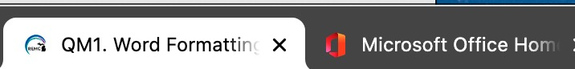  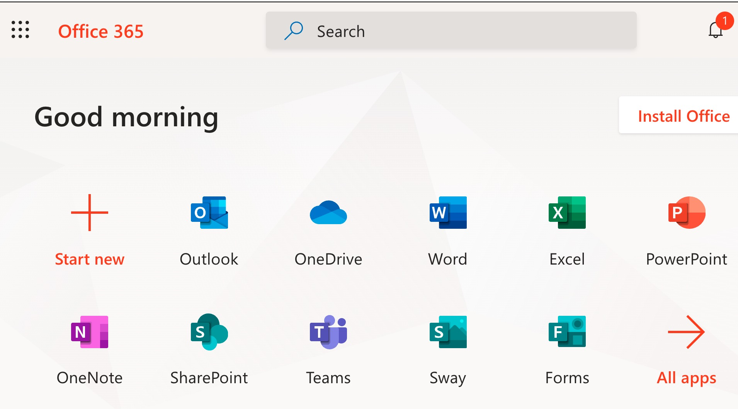
 | Step 2  Select Word | 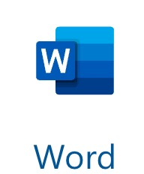
 | Step 3 | Create a New blank document
Note | Your menus are along the top for File, Home, Insert, Layout, References, Review, and so on
Note | Your tools and special features are located below the menus in the “Ribbon” – you can use the up carat at the right-side end of the ribbon to switch between different ribbon views.  Old ribbon:  Newer Ribbon
 | Step 4 | - On the 21t4s page, select the QM1 21things page  - In Word: Open a new Blank Document  - On the QM1 page: For Part 1 Formatting section, select across the Robert Frost Poem (or copy a different poem your teacher may suggest). Copy it (short cut – ctrl-c, cmd-c, or right-click c) .  (Note:  Windows computers use ctrl for actions,  Macintosh uses the cmd key,  right-click can be done with a track pad action or a mouse.  Chromebook, you can press or tap the touchpad with two fingers, or pres Alt and click with one finger.)
 | Step 5 Paste the poem | Paste it into your blank document (shortcut – ctrl-v, cmd-v) exactly as it is
Note | Errors | You should notice Nthing has a red squiggle line under it (indicating a spelling error), and some other words with double-blue lines (possible grammatical errors).
 | Step 6  Run Spelling & Grammar check | - Select the Editor (pen with three lines) to see a list of the errors  - It will list spelling and grammar errors found in the document.
 | Step 7  See spelling suggestions | - Put your cursor on the misspelled word to see some suggestions.  - Select the correct spelling for Nothing and notice it replaces it.
 | Step 8  Look at the grammar highlighted words. | - Now proceed to the grammatical errors.  - flower; is the first one found in this poem.  - You will need to select "ignore" for all of the identified possible errors because this is how Robert Frost actually wrote the poem.
 | Step 9  Add a blank line | - Put your cursor at the end of the first line and press enter (or return) after “Stay”.
 | Step 10  Save your document | - Click at the top where it says Document1 (or other number)  - Type in a name for it such as rfrostpoemXX (XX for your initials). It automatically adds the .docx file ending.  - WAIT!!! Look to see the Location where it is being saved. In this case it may automatically go into a folder ( “My Files” in OneDrive, your district student Folder, your “Documents Folder” or elsewhere) ***Check with your teacher about where your documents are to be saved so you can find them later.  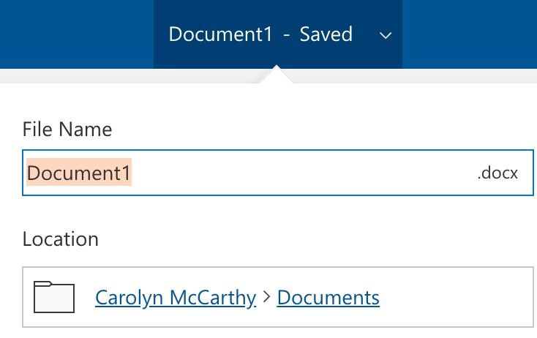
 | Step 11  Change the font style and size | - Put your cursor in anywhere in the document and select-all (ctrl-a, cmd-a, or click at the top and drag down across all the text to select it)– it will look slightly highlighted when selected.  - Go to the Font drop-down arrow, and select a different font style of your choice, and then change the size to 14.  - Click once more to de-select the text.
 | Step 12  Change the title to be a Title Style | - Select the top line of text (try a quick triple-click) and select Title from the Styles tool menu  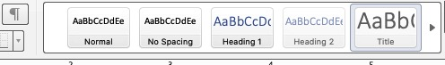
 | Step 13  Bold the word “Eden” | - Select the word, use the B on the tool bar (or ctrl-b, or cmd-b)
 | Step 14  Look up the word using Smart Lookup | - Select the References tab, click on the word Eden and use the Smart Lookup icon (magnifying class with i inside it.  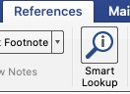 Notice the references and definitions that appear in the Smart Lookup panel. There are two sections to it, Explore and Define. Look at each. This can be a really great tool. Try it on another word, such as “Nature’s” in the poem.
 | Step 15  Make the author’s name italics | - Select the line “By Robert Frost” and be sure you have returned to the Home tab to locate the icon for Italics. (shortcut – ctrl-i, or cmd-i)
 | Step 16  Underline the title and options | - Select the title and use the underline tool (ctrl-u or cmd-u) - but notice if you are using the desktop app that there is a drop-down arrow next to the U icon, check it out for different line types you could choose  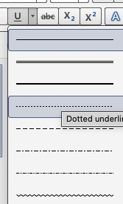
 | Step 17  Choose colored text | - Select a color word such as “green” in the poem, notice that there are two options, a highlighter and text with color on the toolbar with dropdown arrows for color choices.  - Use the text color tool and the word “green”, and the highlighter tool on the word “gold”.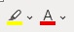
 | Step 18  Alignment tools | - Put your mouse in the title and select the different alignment tools and choose the one you like the best.
 | Step 19  Add your credits at the bottom | - Space down a line or two below the author’s line and add Edited by …. (your name) –  - Change the font style to something that looks fun or like script writing like Apple Chancery.
 | Step 20  SAVE | Click the disc icon to be sure your changes have been saved if you are using the Desktop App version of Word.  If you are using the online version of Word, you will that it is being automatically saved.
End of Part 1 | Example Screenshot | 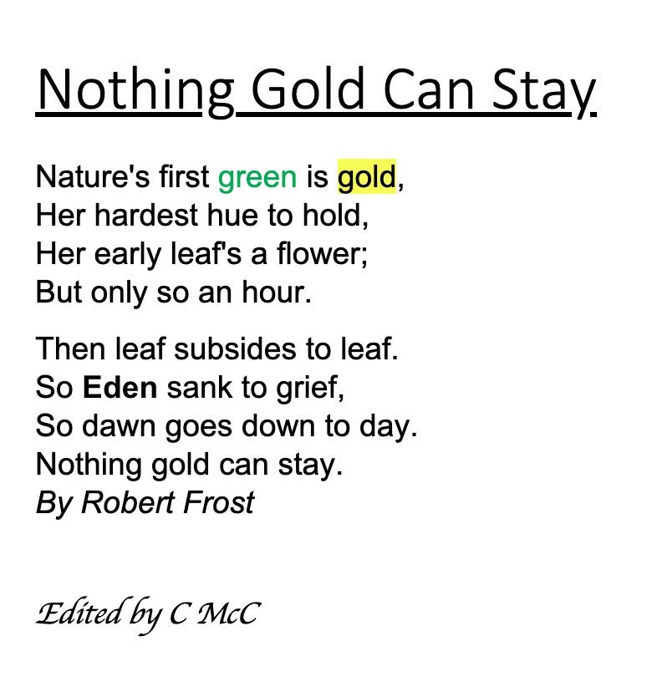

Checklist and steps for Part 2 Formatting in Word with Microsoft Office 365

Step-by-step directions for inserting a page number and comments, getting the word count, use translation, change between different views

CK | Action | Description
 | Step 1 | - Watch the Part 2 video  Pause and replay as often as needed to follow the steps.
 | Step 2  Add a page number to your document | - Use the Insert menu and look at the drop-down arrow next to Page Numbers.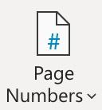 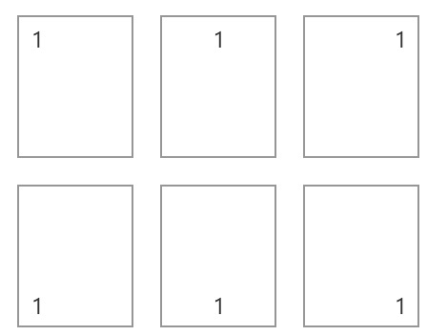  - The drop-down arrow will give you options of where you want your pages numbered. Select one you prefer. Microsoft will add the numbers automatically as you add more pages.
 | Step 3  Insert a comment | - Look over your poem and select a word or line that you want to add a comment about. For example, using the spotlight tool (References menu), select a word you want to know more about and use the spotlight tool. This might be a definition. Copy the information.  - Go to the Review menu, highlight the word you selected, and select +New Comment  and paste the information you copied, or write your own comment.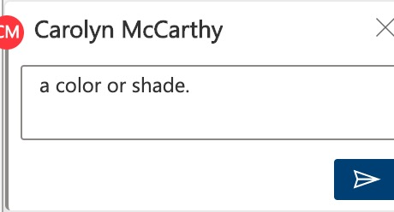 and post it.  Note: Posting comments is one way your teacher can give you feedback, or you can give feedback to a classmate that shares their document with you. This feature is very helpful when you are working on a document together.
 | Step 4 | Select the … (three dots) by the comment 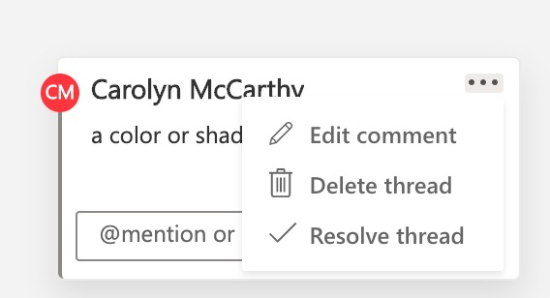 someone leaves (your teacher for example), when they checked your writing and leaves a suggestion for you. Once you make the change you can delete the comment, or edit it to leave a comment back. Resolve thread will remove the comment and indicate you took care o the issue.
 | Step 5  Word count | Sometimes you are directed to write a paper that is less than 20 words. Let’s get a word count of your poem document. On the Review menu look for the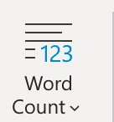 icon. The desktop app version icon has a small ABC with 123 under it icon.  Look at the bottom of your document to see it (it might be already turned on by default).
 | Step 6  Translation | On the Review menu is an amazing tool and great if you have a friend that speaks a different language or you are learning a foreign language. 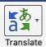 You can select to have it translate something you select, or the entire document. Give it a try! There are over 70 choices you can make. Notice you can view the original document.
 | Step 7  Views | This is only if you are using the desktop app version. Explore some of the options of the View menu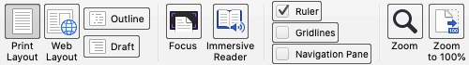  Print layout view (most likely what you were in), this shows what it will look like when printed out. You can also zoom out to see more than one page.  Web layout view  Outline view  Draft view - shows just the text without margins, images, or page breaks.  Focus You can use esc to get out of it and back to your regular view.  You will learn about Immersive reader in Quest 6.
 |  | Check with your teacher for completing this Quest and then check this Quest off on your Roadmap.

